### Monitoring Changes in Almond Pollination Rental Fees

### Kathy Baylis 1, Jai Holt1, Jessica Pasciak1,

### Karen Rennich2, Jennie Stitzinger2, Dennis vanEngelsdorp2, Guyu Ye 1

### 1 University of Illinois, 2University of Maryland, 3 Bee Informed Partnership

Keywords: Honey bee, Pollination, Almonds

**Abstract:**

Almonds rely on honey bees for pollination and the California Almond industry has experienced a three-fold increase in rental fees from 1970 to today including the highest increase of 19% from 2013 to 2014. In this study, we surveyed honey bee brokers over the five year period from 2010-2014 to gain information about the quantity, quality, availability and price of colonies rented for California Almond pollination. We find that rental prices respond to increases in almond acreage as well as changes in colony overwintering loss. The increased demand coupled with tight supply resulted from high loss rates has led colony rental fees to increase dramatically over the past 5 years, costing the almond industry an extra $93 million. When adjusted for the number of frames, rental prices fell slightly in 2014, reflecting lower overwintering losses and higher supply. We argue that quality of colonies needs to be taken into account when considering the trends in pollination cost, as quality-adjusted prices do follow losses and thus supply.

**Introduction:**

Honey bees play a vital role in the agricultural economy within the United States and abroad because of the pollination services they provide. Farmers use honey bees to pollinate berries, fruits, vegetables, and nut crops adding an estimated $15 billion in crop value within the United States (Calderone, 2012). The US almond crop is almost completely dependent on managed bees for pollination (USDA 2013). Almond farmers rent bee colonies from bee brokers for the almond bloom, which starts in February. The brokers coordinate with beekeepers to obtain an adequate supply of healthy hives to meet the demand of the almond growers. Brokers contract with beekeepers from as far away as Florida for 60% of all US honey bee colonies for the almond pollination (USDA 2014).

With an increasing demand for almonds and growing almond acreage, the demand for bees for pollination has been steadily increasing as well. Despite recent water constraints, almond growers are expanding their orchards, doubling the number of acres over the past 20 years (Barringer, 2014). During the five years of our survey from 2010-2014, the number of bearing acres increased by about 16.2% (USDA NASS 2014). Brokers recommend that almond growers stock 2 8-frame colonies per bearing acre of almonds (Traynor, 2013), implying that the demand for bee colonies increased from 1.48 million to 1.72 million from 2010 to 2014.

Beekeepers’ ability to meet the demand for bee colonies has been hampered over the last eight years by the high rates of bee losses from a variety of known and unknown causes. In 2006, beekeepers lost as many as 30-90% of their colonies, much higher than the estimated winter losses of 5-10% they experienced prior to 2005. Even though the most recent year saw a decrease in over-wintering loss, the average loss rate since 2006 has been around 30% (Steinhauer et al, 2015). According to the results of the Bee Informed Partnership Management Survey, 23.2% of managed colonies were lost over the winter ending in 2014 compared to 31.1% in 2013, 21.9% in 2012 and 30% in 2011 (Lee et al 2015; Steinhauer et al, 2014; Spleen et al, 2013; vanEngelsdorp et al, 2012). Causes for the high loss rates include bee parasites, such as the Varroa destructor and Nosema parasite, poor nutrition, pesticides, climate, bee management and/or a combination of these factors. The reduction in the supply of domestic bees has put upward pressure on colony rental prices.

This increase in demand and decline in supply of bees have been reflected in the price of pollination services. Survey data from the California State Beekeeping Association indicates that the price of renting bees for almond pollination increased at a modest rate until 2005 when it jumped from $70 to $138 in 2006, the year when CCD started to be reported (Sumner 2006, Heintz 2012, CCD Steering Committee USDA 2007). According the California State Beekeeping survey, the rental price has continued to rise up to $182 in 2014 (see Figure 1).

Previous literature has concluded several factors affecting bee colony rental prices for almond pollination, including market force as well as the opportunity cost and transportation cost associated with providing pollination services for the almond industry. Sumner (2006) notes the market forces pushing the rental price upward in the years before 2006 included a decrease in supply of bees as a result of bee disease and an increase in demand for bees for pollination in almonds as a result of the expansion of the almond market. In addition, Sumner observes that demand for almond pollination is expanding at a faster rate than demand for pollination in other crops. Almonds bloom has little value for beekeepers because almond nectar does not produce honey that is desirable for human consumption. As a result, beekeepers that supply almond growers with bees require almond pollination rental fees that are high enough to compensate them for the opportunity cost from producing honey. Increases in diesel price also put upward pressure on almond pollination fees since transportation is a major component of beekeepers’ costs particularly for beekeepers who truck their hives from the east coast for the almond bloom (Rucker, Thurman and Burgett 2012).

In this paper, we explore how pollination contracts have evolved to address this increased demand for bees. These bee rental agreements are usually set up as early as the previous June and thus is relatively fixed prior to the almond bloom. They vary with the arrangements between almond growers and beekeepers, and some provide incentives to beekeepers for providing high quality hives. We use novel data collected from the bee brokers by the Bee Informed Partnership, and find that when the quality of bees are considered, the movement of colony rental prices is consistent with the overwintering loss rates of bees. This result implies that measuring bee availability using numbers of colonies may not be as effective as using frames of bees.

We see the following contributions of this paper. First of all, this is the first report using the responses from bee brokers, the link between almond growers and beekeepers, to comprehensively gauge the almond pollination market. Secondly, we address the issue of variations in colony qualities by calculating frame-weighted prices as well as adjusting for inflation in order to realistically compare almond pollination fees over the years.

**Data and Methods**

Since 2010, the Bee Informed Partnership have collected data on the almond pollination market through phone interviews with bee brokers. Bee brokers are defined as individuals who place bees for more than 2 beekeepers and more than 2 different almond orchards. The brokers are contacted after the almond bloom, from the beginning of March until the end of April. The Bee Informed Partnership interviewers read brokers an implied consent statement before conducting the survey. The interviewers inform the brokers that they are not required to answer all of the questions and could opt out of answering any questions they are not comfortable with. Brokers who agree to complete the survey were asked the following questions:

1. How many colonies did you place in almond orchards this year?
2. How many colonies did you place in almonds last year?
3. Given an unlimited supply, how many colonies could you have placed in almond orchards this year?
4. If an additional almond orchard with 100 acres needed bees from you this past season, would you have been able to supply those bees?
5. What % of the colonies that you placed in almonds were “field run”?
6. What was the average number of colonies you placed per acre?
7. What was the highest number of colonies you placed per acre?
8. What was the lowest number of colonies you placed per acre?
9. What was the average number of colonies you placed per acre last year?
10. How many different beekeepers (including yourself) did you place colonies for this year?
11. How many different almond growers did you place colonies for this year?
12. How many beekeepers that you broker for (including yourself) had difficulty meeting the number of colonies they committed for pollination?
13. How many colonies, that were committed for pollination, were you and/or those beekeepers you broker for short?
14. What was the average grade of the colonies you placed?
15. What was the average price you received per placed colony?
16. What was the lowest price received?
17. What was the highest price received?
18. What percentage of the hives that you broker for are managed year round in California exclusively?
19. What percentage of the almonds growers that you supplied with bees this year, did you supply bees to last year as well?
20. What percentage of beekeepers that you brokered for did you broker for last year as well?

This survey fills in the gaps in the available survey data, including the Pacific Northwest (PNW) Honey Bee Pollination Survey conducted by Oregon State University and the California Almond Forecasts by California Almond Board. The PNW survey, started in 1986, is concerned about the pollination economics in the Pacific Northwest states such as Oregon, Washington and Idaho. The annual California Almond Forecasts only provide us with a broad sense of the almond market. However, the Tier 6 survey conducted by the Bee Informed Partnership covers the five year period from 2010 to 2014. It collects data on rental price, number of colonies placed, colony shortages as well as colony grades for almond pollination from almond brokers. Since these brokers are the intermediate person between beekeepers and almond growers, they have a better understanding of both markets. With the information they provide, we can get a broad and detailed idea of the almond pollination market.

We took a subsample of the responding brokers who completed the survey in all 5 years. Using this panel of subsample, we were able to look at fluctuations within the almond pollination market. We analyzed the answers to questions 4 through 9 and 14 through 17 by taking the colony weighted average of these responses. To determine the colony weighted average, each broker’s responses were weighted by the number of colonies he or she placed during the survey year. The colony weighted average is a more accurate measure of the overall industry average than a simple average since the size the brokers’ operations vary significantly (in 2014 the smallest broker operation in the subsample placed 2,800 colonies while the largest placed 90,000 colonies). The number of colonies placed by a broker is reflective of the broker’s operation size.

One increasingly important consideration in the pollination market is that bee colonies vary in quality. Colonies are graded based on number of bees in the colony. These grades are calculated in terms of the number of frames the bees that inhabit in the hive. We find that the quality of the colonies placed varies over the survey period. The quality variation makes it difficult to compare supply and prices across time periods. We address this obstacle by analyzing supply of bees on a frame basis and by creating a quality adjusted colony rental price.

Traditionally the supply of bees is calculated by the number of colonies placed. This is done for practical purposes because it would be difficult to estimate the number of bees used for pollination. However, most colonies placed for pollination are graded which helps to approximate the number of bees within the colony. Using colony grade in combination with the number of colonies placed, we estimate of the supply of bee that contributes to pollination services by looking at the bee supply on a frame basis. We estimate the total number of frames provided by taking the average grade of the colonies placed by each broker times the number of colonies that the broker and sum the results.

To deal with the impact of quality variation on rental price, we created a quality-adjusted colony rental price measure. First, we calculated the rental price per frame by dividing each broker’s average rental price by the average grade of the colonies the broker placed. Then we multiplied this number by the overall average colony grade for the subsample of brokers over the survey period. This method brings colonies in different years to the same quality level and thus removes the bias resulted from quality differences.

Last but not the least, to increase the comparability of prices over the years, we adjusted rental prices for inflation. We set the base year as 2014 in order to see how rental prices during the previous years would be like should they were set last year. By using the CPI Inflation calculator on the website of Bureau of Labor Statistics, we were able to bring all the prices to last year’s level and get a more realistic understanding of the colony rentals in almond pollination.

**Results**

BIP collected responses from 23 bee brokers in 2010 and 2011, 16 brokers in 2012, 20 brokers in 2013 and 17 brokers in 2014 (see Table 6-8). Twelve bee brokers (hereafter referred to as “core brokers”) gave responses in all five years. This subsample represents approximately 30-40% of the total number of bee brokers in the industry (which has a total of 30-40 brokers). Here we examine the survey results from this subsample of core brokers to determine trends in the almond pollination markets over the period from 2010 to 2014.

Bee Supply

The number of colonies placed by core brokers for almond pollination varied over the survey period (see Table 2). In 2014, the number of colonies placed by the 12 brokers surveyed was 228,572, representing about 16% of the estimated 1.4 million colonies used for California almond pollination that year (USDA 2014). The largest change in the number of colonies placed occurred between 2010 and 2011 with an 11.6% increase in the number of colonies placed. Between 2011 and 2012 the number of colonies placed by core brokers declined by 1.9%. In 2013, the number of colonies placed was about the same as the previous year, and in 2014, the number of colonies placed decreased by about 2.9% from the previous year (see Figure 2).

For an alternative view of the supply of bees provided for pollination services by the surveyed brokers we estimated the number of frames of bees the brokers supplied for pollination. The changes in supply of frames are similar to the changes in the supply of colonies between 2010 and 2012. In 2014, the number of frames of bees supplied increased 22% as compared to 2013 while the number of colonies supplied decreased by 16% during the same period (see Table 2). This result indicates that the number of colonies placed alone does not necessarily represent the true supply of available pollinators.

The variation in the number of colonies placed over the time period is modest considering the substantial increase in the number of almond bearing acres over the survey period (see Table 1). We find that the number of colonies placed per acre is relatively stable over the survey period at around the recommended 2 colonies per acre in both the subsample and the full sample (see Table 3 and Table 6). However, the quality of those colonies was not consistent over the survey period. The lowest colony grade in the subsample over the survey period was 7.9 frames in 2013 and the highest grade was 9.7 in 2014 (see Table 2).

Bee Shortage

In all five years at least some of the beekeepers sourcing the surveyed brokers were short bees. In 2013, the largest shortage occurred with beekeepers having 30,997 fewer colonies available than were committed in pollination contracts, representing approximately 27% of all colonies placed by the core brokers in 2013. The percent of colonies committed by brokers but were short relative to the number of colonies placed was markedly lower in both 2012 and 2014 going no higher than 3% ( table 4). In 2013, bee brokers also reported that they were less able to respond to requests for more bees. In response to the question “If an additional almond orchard with 100 acres needed bees from you this past season, would you have been able to supply those bees?” only 33.3% of brokers responded yes in 2013 and 41.7% in 2014 as compared with 91.7% in 2011 and 2012 (no data were available for 2010).

Bee Demand

Newer orchards that are just beginning to bear require less densities of colonies with less flowers, so the number of colonies placed for older orchards per acre is comparatively higher. Given the survey result that almond growers on average placed 2 colonies per acre, we predict that the demand for colonies in 2014 was about 1.72 million. This represents an approximate 40,000 colony increase in demand over 2013. With this 2.4% increase in demand, colony rental price increased significantly by 16.8% than the previous year (see Table 5). As illustrated in Figure 1, the colony-weighted average price was $150.78, $159.86, $158.12, $155.92 and $182.11 in 2010, 2011, 2012, 2013, and 2014 respectively after being adjusted to 2014 level. Therefore, the increase in price between 2010 and 2014 was about 20.8%.

Factors Driving the Prices

The supply of bees is an evident factor that drives up the colony rental price. We asked the brokers this question “How many colonies, that were committed for pollination, were you and/or those beekeepers you broker for short?”. By summing those numbers, we get the colony shortage for our core brokers (see Figure 2). When comparing these shortages with the overwintering loss rates of bees over the past five years, we can clearly see that the large shortages in 2012 and 2013 could be explained by the large overwintering loss rates (see Figure 3). Statistically, the correlation coefficient between these two variables is 0.71, even though the p-value is very large due to a small sample size.

With the lower overwintering loss rates, lower shortages and only modest increase in almond acreage (NASS 2014), one might have expected rental prices to ease somewhat in 2014. While we observe an increase in the colony rental price, the frame adjusted colony rental price was down at $168.97 in 2014 as compared to $180.51 in 2013, a 6.4% decrease (see Figure 1 and Table 5). When putting the rental prices of colonies and overwintering loss rates of bees together, we can see that the frame-weighted rental price has a similar trend as the honey bee loss rates (See Figure 4). This result shows that when quality is taken into consideration, colony rental price can be explained by the overwintering loss of bees. So, even though there is a 20.8% increase in colony rental price when unadjusted prices are observed, the frame-weighted price might be a better measurement with a 4.6% price increase over the past five years.

**Discussion:**

With the rise in rental cost for almond pollination, the per colony rental price has been on an increasing trend. Especially during the year of 2014, rental price has increased drastically. However, further exploration of the data indicates that it may be necessary to reevaluate the effectiveness of using colonies as a measure of availability since the grade of colonies placed can vary considerably from year to year. Measuring pollinator availability on a per frame basis provides further insight into the health of the honey bee industry. When grade adjusted prices are used to examine colony rental price we find that the rental price in 2014 decreased about 6.4%. The small decrease in the rental price of colonies was driven by an increased number of frames supplied over the survey period, a decreased overwintering loss of honey bees despite an increase in almond bearing land. Over the survey period, the cost of pollination to almond industry has increased from roughly $245 million to $282 million when prices are adjusted to the 2014 level. As almond acreage continues to expand, we expect further increases in the cost of renting bees for pollination, and we expect this price to be affected by national honey bee health.

**Conclusion:**

First, we find that pollination in the Almond industry has been affected by the increase in mortality of honey bees. When we consider the frame-weighted average rental rate, we see that it is negatively correlated with overwintering loss, and that during years of high loss (e.g. 2012), the number of frames per colony placed dropped and the number of shortages felt by bee brokers rose dramatically.

We then explore the potential correlation between overwintering loss and the colony rental prices measured in two ways. According to Table 12, both prices are negatively correlated with overwintering loss of bees. The results of our analysis indicate that it would be beneficial to consider colony grade when evaluating changes in almond pollination markets. When we examine quality adjusted colony rental prices, which corresponds to the changes in overwintering loss rates of bees, we find that there is more fluctuation in almond pollination pricing between years than with unadjusted prices. Also, colony grade should be considered when quantifying the supply of bees for almond pollination. We demonstrate one method of accounting for changes in colony quality by looking at the frame level supply of bees rather than the colony level.

Pollination surveys conducted by the California State Beekeeping Association suggest that the almond pollination fees has increased from $153.42 in 2012 to $158.99 in 2013 (CSBA 2013). After adjusting for inflation, we are essentially looking at a $3.38 increase in colony rental fees from $158.19 to $161.57 in 2013. The estimate for 2012 price is very close to our result; even though the price in 2013 also shows an increase according to this survey, our frame-weighted approach displays a much larger jump. This survey also projects the average almond pollination fee to be $169.79 in 2014, which is very close to our result of $168.97. In addition, two surveys collecting information from beekeepers show that the average almond pollination fee was $150.30 in the west coast and $75.80 in the east coast in 2009 (Caron, 2011). Even though these results reflect the pollination market reality before our survey period, an inflation-adjusted price of $165.85 in 2014 dollar in the west coast is very close to our estimate of $161.55 in 2010. Consistency with the results from other surveys show that our approach to measure almond pollination fees is reasonable.

**Acknowledgements:**

We would like to thank the brokers for their responses and continued support of research on almond pollination markets. We would also like to thank the USDA??? for its grant support.

References:

Barringer, Felicity. 2014. “Water Source for Almonds in California May Run Dry”. T*he New York Times*. December 27. http://www.nytimes.com/2014/12/28/us/water-source-for-almonds-in-california-may-run-dry.html.

Calderone, N. W. (2012). "Insect Pollinated Crops, Insect Pollinators and US Agriculture: Trend Analysis of Aggregate Data for the Period 1992–2009." *PloS ONE 7(5)*: e37235.

California State Beekeeping Association. “2013 Pollination Survey.” *CSBA Beekeepers Toolbox.* <http://www.californiastatebeekeepers.com/resources/2013-Pollination-Survey%20.pdf> (accessed June 3, 2015)

Caron, Dewey. (2011). “Bee Colony Pollination Rental Prices, Eastern US with Comparison to West Coast.” *Mid-Atlantic Apiculture Research and Extension Consortium.* <https://agdev.anr.udel.edu/maarec/wp-content/uploads/2011/02/Pollination-rentals-PNWEAST.pdf> (accessed June 3, 2015)

CCD Steering Committee USDA. "Colony Collapse Disorder Action Plan." *United States Department of Agriculture.* June 20, 2007. http://www.ars.usda.gov/is/br/ccd/ccd_actionplan.pdf (accessed March 12, 2013).

Heintz, Chris. "Honey Bee Health And Supply." *California Almonds: Almond Board of California.* 2012. http://www.almondboard.com/Handlers/Documents/Honey%20Bee%20Health%20and%20Supply.pdf (accessed May 15, 2013).

Oliver, Randy. "2012 Almond Pollination Updatec." *ScientificBeekeeping.com: Beekeeping Through the Eyes of a Biologist.* April 2012. http://scientificbeekeeping.com/2012-almond-pollination-update/ (accessed May 15, 2013).

Spleen, A. M., et al. (2013). "A national survey of managed honey bee 2011-12 winter colony losses in the United States: results from the Bee Informed Partnership." *Journal of Apicultural Research* ***52***(2).

Steinhauer, N. A., et al. (2014). "A national survey of managed honey bee 2012-2013 annual colony losses in the USA: results from the Bee Informed Partnership." *Journal of Apicultural Research* ***53****(1)*: 1-18.

Steinhauer, N. A., et al. (2015). "Colony Loss 2014-2015: Preliminary Results." *Bee Informed Partnership.* May 13. <http://beeinformed.org/2015/05/colony-loss-2014-2015-preliminary-results/> (accessed May 23, 2015)

Sumner, Daniel. "Bee-conomics and the Leap in Pollination Fees." *Agricultural and Resource Economics Update* 9, no. 3 (2006): 8-11.

Traynor, Joe. "1,2,3: Almond Pollination Math by Joe Traynor." *Project Apis M.* January 2013. http://projectapism.org/content/view/208/27/ (accessed May 17, 2013).

United States Department of Agriculture National Agricultural Statistics Service. "2014 California Almond Forecast." *California Almonds: Almond Board of California.* Deccember 15, 2014. http://www.almondboard.com/AboutTheAlmondBoard/Documents/201405almpd.pdf (accessed December 15, 2014).

United States Department of Agriculture National Agricultural Statistics Service. "2014 California Almond Nursery Sales Report." *Circle of Blue.* August 1, 2014. http://www.circleofblue.org/waternews/wp-content/uploads/2014/08/USDA_NASS_CAalmondsurvey.pdf (accessed March 4, 2015).

USDA. "Honey Bees and Colony Collapse Disorder." *USDA News & Events.* April 2, 2013. http://www.ars.usda.gov/News/docs.htm?docid=15572 (accessed May 1, 2013).

—. "Honey Bees and Colony Collapse Disorder." *USDA News & Events.* April 2, 2013. http://www.ars.usda.gov/News/docs.htm?docid=15572 (accessed May 1, 2013).

vanEngelsdorp, Dennis, et al. "Winter Loss Survey 2012 – 2013: Preliminary Results." *Bee Informed Partnership.* May 1, 2013. http://beeinformed.org/2013/05/winter-loss-survey-2012-2013/ (accessed May 19, 2013).

vanEngelsdorp, D., et al. (2012). "A national survey of managed honey bee 2010-11 winter colony losses in the USA: results from the Bee Informed Partnership." *Journal of Apicultural Research* **51**(1): 115-124.

Appendix (Figures and Tables):

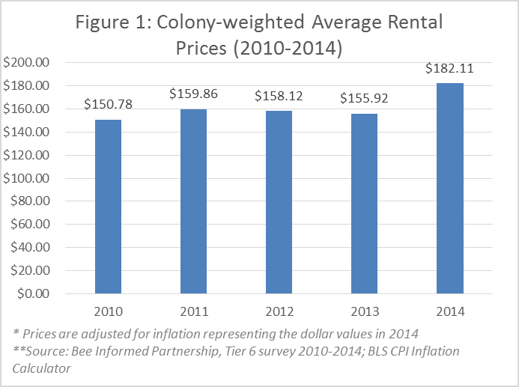

Figure 1

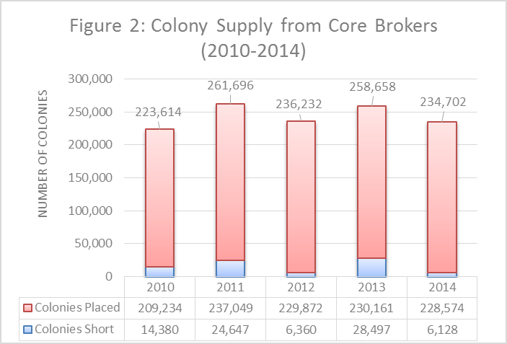

Figure 2

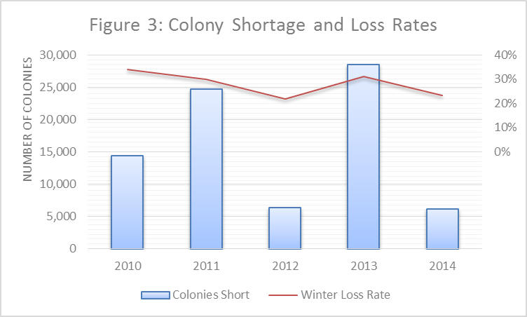

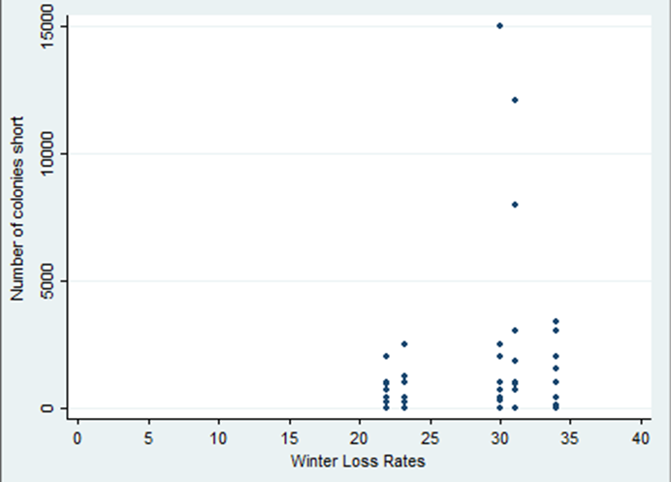

Figure 3

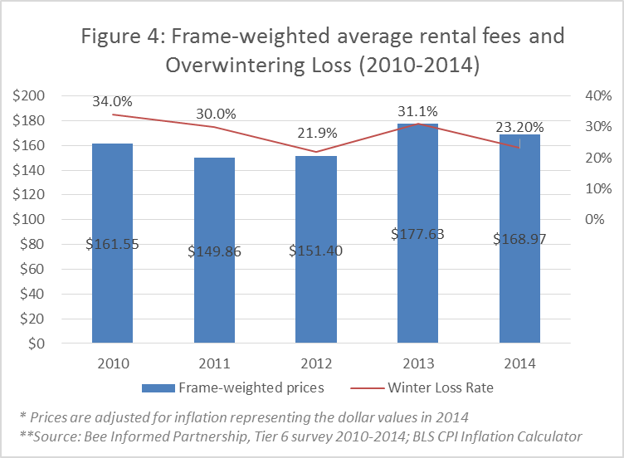

Figure 4

Tables:

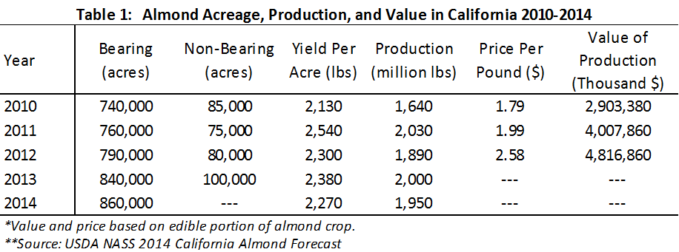

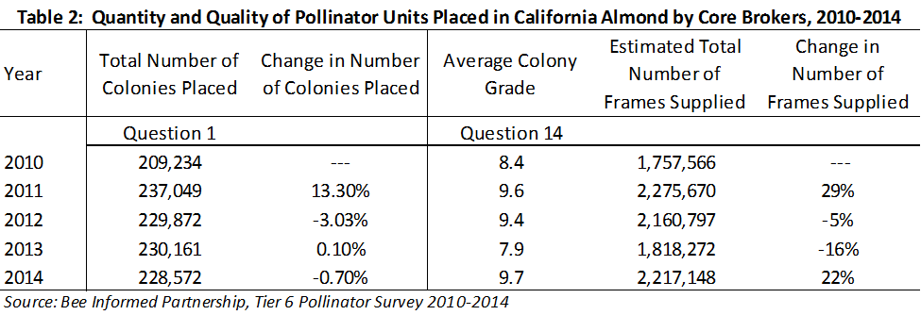

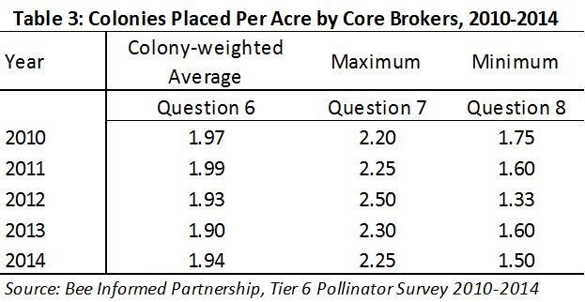

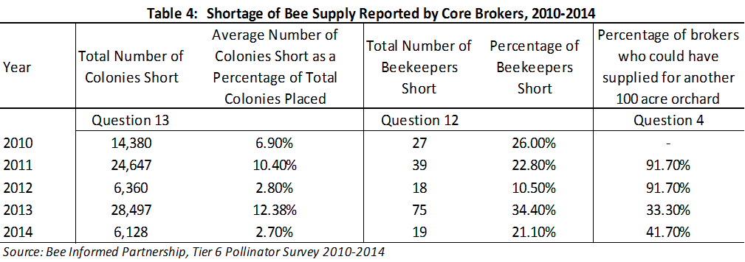

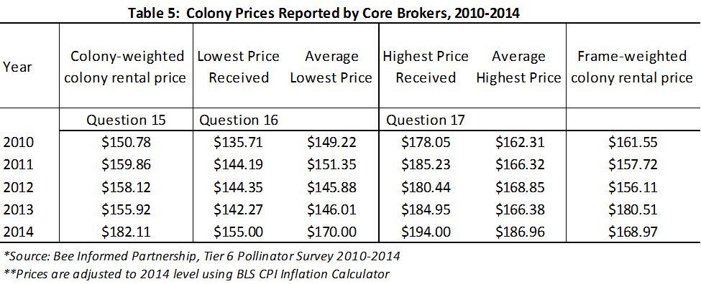

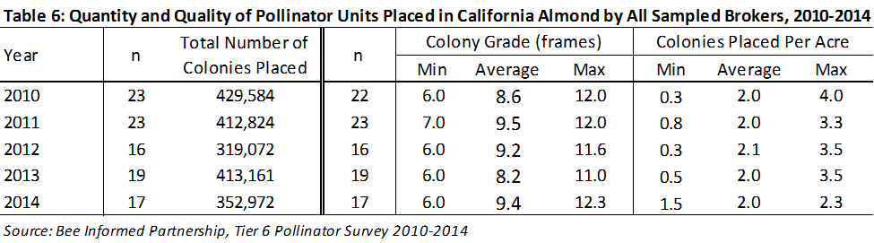

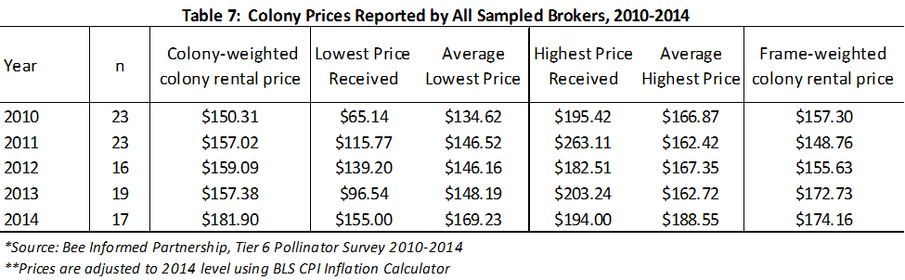

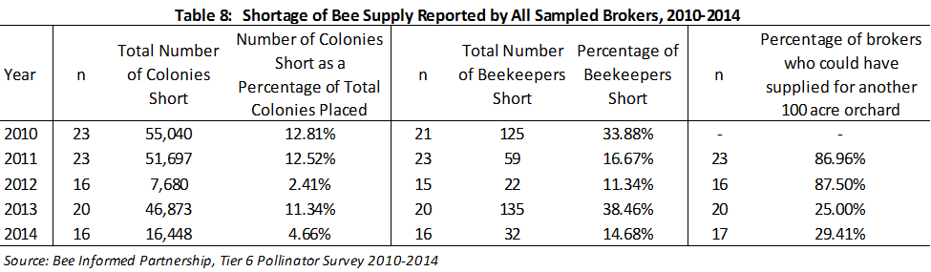

Hi Mr/Mrs. ______________________, this is _______. I am calling as part of the Bee Informed partnership, a consortium of bee researchers who want to gauge the availability of pollinator units in California Almonds.

Is now a good time to talk? Yes – proceed

No – when can I call back

I’m calling you because I understand that you broker bees for placement in California almonds. I hope you will be willing to answer some questions about the availability and quality of pollinating units in Almonds. We hope to do similar surveys in future years too as a way to indirectly measure the health of the honey bee industry.

In all this survey is composed of 20 questions and it should take about 10 minutes to complete.

Your participation in this survey is completely voluntary and you should feel under no obligation to participate. If you do decide to participate you should feel free to refuse to answer any questions or stop the survey altogether at any time. Your decision to participate or not, as well as the answers you provide should you want to participate, will be kept strictly confidential. Any reports coming out of this study will not identify you in any way, and we will never share any information with anyone that will link any of your personal information with the answers that you give.

So do you think you will be willing to participate in this survey.

Yes – proceed

No – Ok thanks for your time.

Ok great. Since this survey will ask some questions about your business it is governed by certain laws designed to protect your rights and freedoms. We are therefore required to ask you a couple of questions to be sure we are permitted to include your responses in this study and also give you some information regarding your rights and what we will do to protect your privacy.

First I need to confirm you are at least 18 years old.

Yes – proceed

No – Oh, thanks for your interest but unfortunately we are not able to include your responses in this survey.

OK – great. We realize that you may want to ask researchers more questions about this survey, so I want to give you the opportunity to take down Dennis vanEngelsdorp’s, the lead investigator for this study, phone number in case you have some follow up questions. Do you want this number? 717-884-2147.You should also feel free to call the Penn State office that oversees this kind of research if you have questions or comments. Do you want their number? (814) 865-1775.

Ok lets get started.